Citizenship, Economics and Society (Secondary 1-3)
“3-minute Concept” Animated Video Clips Series:
“Stereotype, Prejudice and Discrimination”
Teaching Guidelines

1. Title of the animated video clip: “Stereotype, Prejudice and Discrimination”
2. Duration of the animated video clip: Around 3 minutes
3. Related CES Module(s): Module 1.2 Interpersonal Relationships and Social Inclusiveness, Module 1.4 Rights and Duties
4. Introduction of the animated video clip: The animated video clip was developed by the Personal, Social and Humanities Education Section, Curriculum Development Institute, Education Bureau. It uses daily examples and simple language to succinctly explain the concept of “Stereotype, Prejudice and Discrimination”.
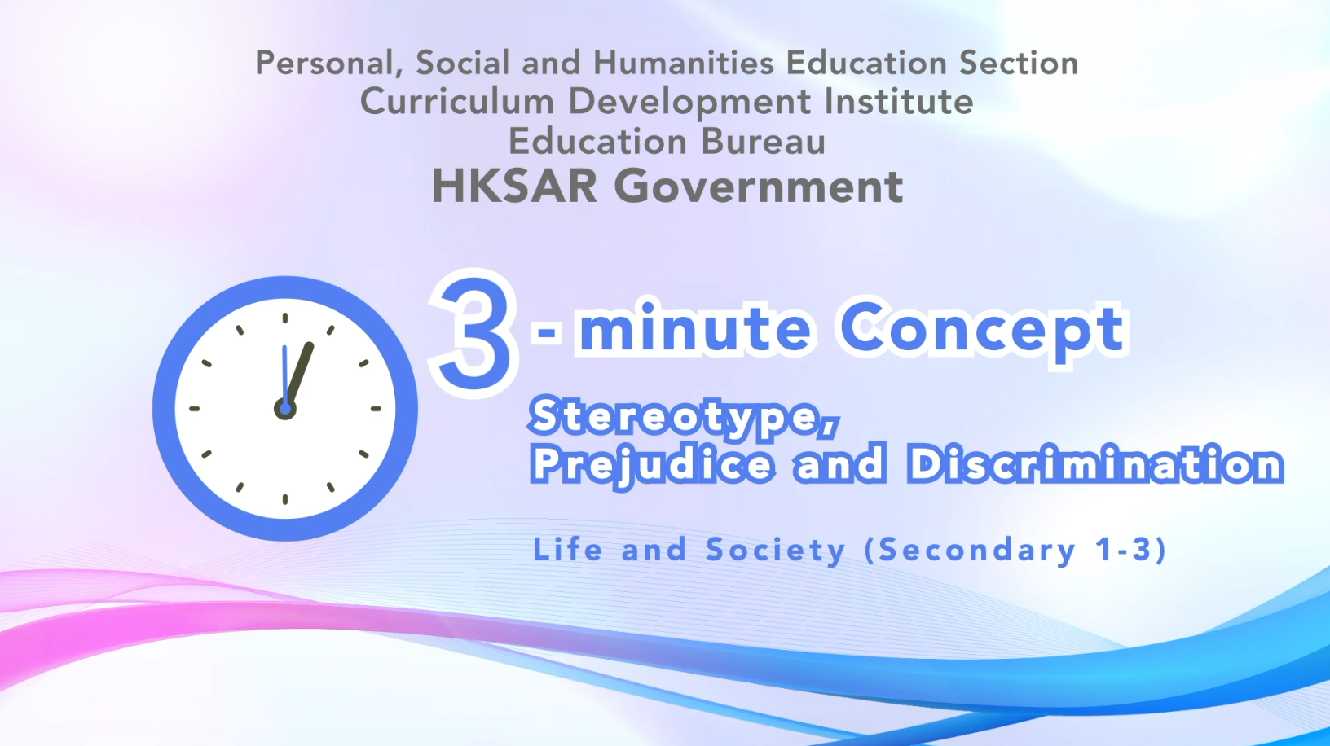
Citizenship, Economics and Society (Secondary 1-3)
Video link: https://emm.edcity.hk/media/Citizenship%2C+Economics+and+Society+%223-minute+Concept%22+Animated+Video+Clips+SeriesA+%2810%29+Stereotype%2C+Prejudice+and+Discrimination+%28English+subtitles+available%29/1_6carn4jd
5. Teaching tips: Teachers must explain the following main points to students after playing the “Stereotype, Prejudice and Discrimination” animated video clip:
1) Anti-discrimination legislation and related legal liabilities | Teachers should point out to students that Hong Kong is an international city that respects the rule of law, equality and freedom. In existing Hong Kong legislation, the ordinances that prevent discrimination include the Sex Discrimination Ordinance, the Disability Discrimination Ordinance, the Family Status Discrimination Ordinance, the Race Discrimination Ordinance, etc. Teachers should further point out to students that everyone is equal before the law and that discrimination against others may breach the law and be subject to legal liability. For details on the anti-discrimination ordinances, please refer to the following resources:  Hong Kong e-legislation  https://www.elegislation.gov.hk/  Equal Opportunities Commission - Discrimination Laws  https://www.eoc.org.hk/en
2) Policies on elimination of stereotyping, prejudice and discrimination by the Government of the Hong Kong Special Administrative Region | Teachers should point out to students that the Government of the Hong Kong Special Administrative Region is committed to promoting equal opportunities and eliminating all forms of discrimination. Over the years, the Government has implemented a number of legislative, administrative and/or educational measures to ensure that every Hong Kong citizen, regardless of gender, family status, disability, race, etc., enjoys equal opportunities. For the Government’s policies on elimination of stereotyping, prejudice and discrimination, teachers can refer to the following resource:  Constitutional and Mainland Affairs Bureau - Topic Issue - Equal Opportunities  https://www.cmab.gov.hk/en/issues/equal.htm
3) The functions of the Equal Opportunities Commission in eliminating stereotyping, prejudice and discrimination | Established in 1996, the Equal Opportunities Commission (EOC) is a statutory body responsible for implementing and enforcing the four anti-discrimination ordinances in Hong Kong, namely the Sex Discrimination Ordinance, the Disability Discrimination Ordinance, the Family Status Discrimination Ordinance and the Race Discrimination Ordinance. Through handling complaints, conciliating disputes, representing victims in court, conducting empirical research and policy advocacy, and arranging corporate training and public education, the EOC strives to dismantle prejudice in the community, facilitate redress for discrimination, and promote values of equality, diversity and inclusion. For details on the functions of the EOC, teachers can refer to the following resource:  Equal Opportunities Commission - About the EOC  https://www.eoc.org.hk/en/about-the-eoc/introduction-to-eoc
4) Elimination of stereotyping, prejudice and discrimination depends on the concerted efforts of society | Teachers should point out to students that apart from the government, private sectors and the community have different roles and responsibilities in eliminating stereotyping, prejudice and discrimination. Teachers are suggested to explain to students how individuals can fulfil their civic responsibilities and help build a harmonious and equal society, and the private sector’s social responsibilities and specific actions in eliminating stereotyping, prejudice and discrimination. For example, during recruitment, employers should ensure equal employment opportunities and employ people based on their abilities, talents and knowledge instead of turning down candidates just because of their gender, disability, family status, race, age, etc. For guidelines on how to prevent and deal with discrimination in the workplace, teachers can refer to the following resource:  GovHK - Discrimination in the Workplace  https://www.gov.hk/en/residents/employment/labour/discrimination.htm

6. Consolidation questions : (See next page)

“3-minute Concept” Animated Video Clips Series:

“Stereotype, Prejudice and Discrimination”

Worksheet

- Fill-in-the-blank Questions
Put the correct answers in the space provided.
Discrimination refers to any adverse distinction that deprives a person of reasonable treatment made on the basis of:

B. True or False
Study the following sentences about “Stereotype, Prejudice and Discrimination”. Put a “T” in the blank for correct description and an “F” for incorrect description.
 | Stereotype, Prejudice and Discrimination are not related to each other. | F
 | Our impressions about people or things come mainly from our past experiences and the information we receive in daily lives. | T
 | Stereotypes can be reduced through education or interaction with people from different backgrounds. | T

C. Short Question
Explain why prejudices and discrimination are definitely undesirable.
- First, they are not in line with the principle of fairness.
- Second, no one wants to live in a society filled with stereotypes, prejudices and discrimination and become the next victim.

 The End 

